1. **Number of Preorders**

* In 2020, [Wedbush Securities](https://electrek.co/2020/06/22/tesla-cybertruck-pre-orders-rose-over-650000-report/) reported that the number of preorders for Cybertruck has risen to over 650,000.
* A [crowdsource tally](https://docs.google.com/spreadsheets/d/1--6OR9ECwSwZdkOtWkuslJVCyAAfQv1eJal1fdngfsk/edit#gid=982860347) estimated the number of preorders to be over 1 million.
* This put the low estimate at 650,000 preorders and the high estimate at 1,000,000 preorders

1. **Graphs and Data**

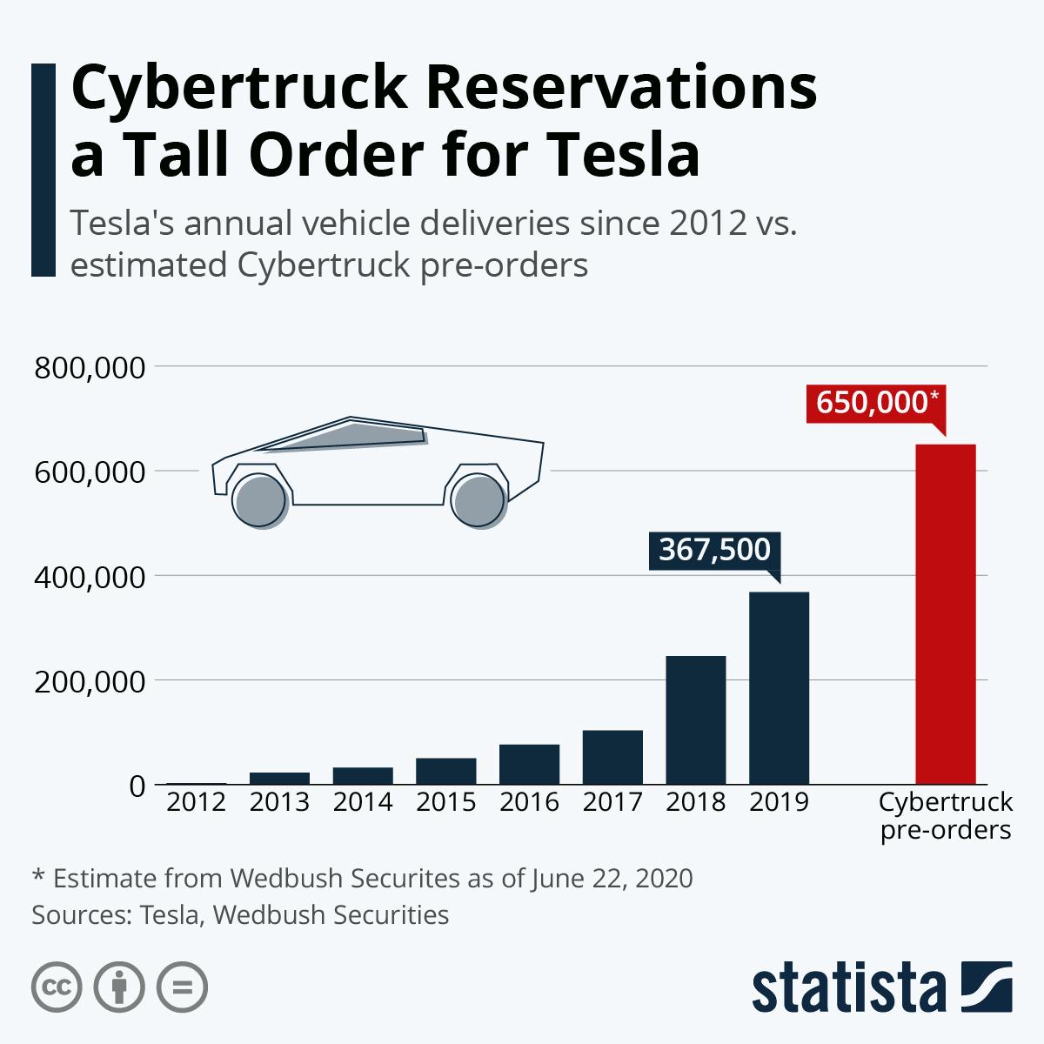

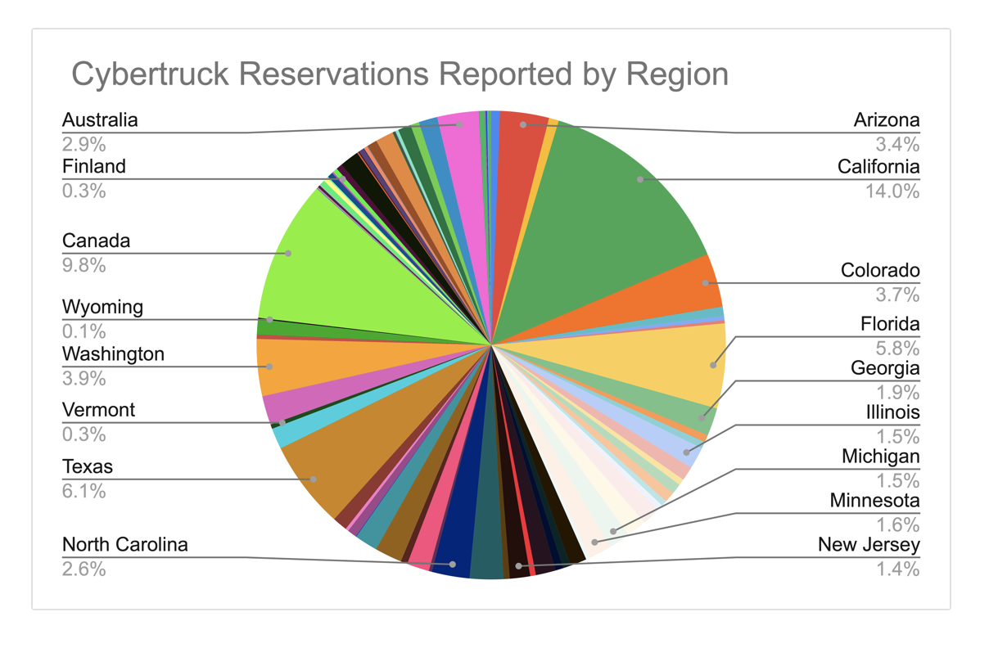

**https://docs.google.com/spreadsheets/d/1--6OR9ECwSwZdkOtWkuslJVCyAAfQv1eJal1fdngfsk/edit#gid=982860347**

1. **News opinion through time**

**2019: Presentation (Curious)**

* A lot of attention on the bulletproof window malfunction
* Many called the product’s design unconventional, unique, and different.

<https://edition.cnn.com/2019/11/22/cars/tesla-cybertruck-electric-pickup-truck/index.html>

<https://www.theverge.com/2019/11/21/20975475/tesla-cybertruck-announcement-musk-electric-truck-pickup-features-range-price-release-date>

<https://www.cnbc.com/2019/11/21/tesla-cybertruck-unveiled.html>

<https://www.wired.com/story/electric-tesla-pickup-truck-announcement-specs-cost-photos/>

**2020: Size and design of the vehicle (Interested)**

* News outlet focused on whether the final size and design of the product will be the same as the prototype.

<https://techcrunch.com/2020/05/23/elon-musk-the-tesla-cybertruck-isnt-getting-any-smaller/>

<https://www.motortrend.com/news/tesla-cybertruck-smaller-world-pickup-likely/>

<https://driving.ca/features/feature-story/motor-mouth-teslas-cybertruck-is-well-we-dont-even-know>

<https://www.greencarreports.com/news/1128270_musk-tesla-cybertruck-won-t-be-downsized-but-smaller-follow-up-truck-a-possibility>

<https://www.motortrend.com/news/tesla-cybertruck-design-elon-musk/>

**2021: Production delayed to 2022 (Dissapointed)**

* Production of the Cybertruck is delayed to 2022
* Many said that the delay might hurt Cybertruck as it has lost its time advantage over competitors

<https://www.insidehook.com/daily_brief/vehicles/tesla-cybertruck-loses-advantage-electric-trucks>

<https://electrek.co/2021/09/02/tesla-delays-cybertruck-late-2022/>

<https://www.theverge.com/2021/8/8/22615539/tesla-cybertruck-production-delayed-2022-elon-musk>

<https://www.inverse.com/innovation/tesla-cybertruck-release-date-elon-musk-just-revealed-whats-going-on>

<https://www.caranddriver.com/news/a37258128/tesla-cybertruck-production-delayed/>